Drive Guide

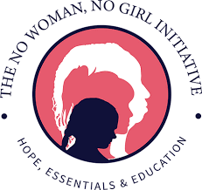

Follow These Simple Steps to Make an Immediate Impact!
- Grab a box or container.
- Place the “Donation Collection Box” sheet on your box or container.
- Tell your friends, family or co-workers about your drive.
- Host your drive.
- Contact us when your drive is complete!

Our Vision
No woman and no girl will go without access to everyday essentials to survive crisis or transition.

Items We Accept
- Shampoo
- Conditioner
- Floss
- Toothpaste
- Toothbrushes
- Deodorant
- Hand sanitizer
- Body wash
- Bar soap
- Body lotion
- Washcloths
- Pads
- Tampons
- Pantyliners
- Feminine hygiene wipes

Contact Us!
To learn more about supporting our mission or questions about how to donate large quantities of items collected, please email hello@nowomannogirl.org.
DONATION COLLECTION BOX

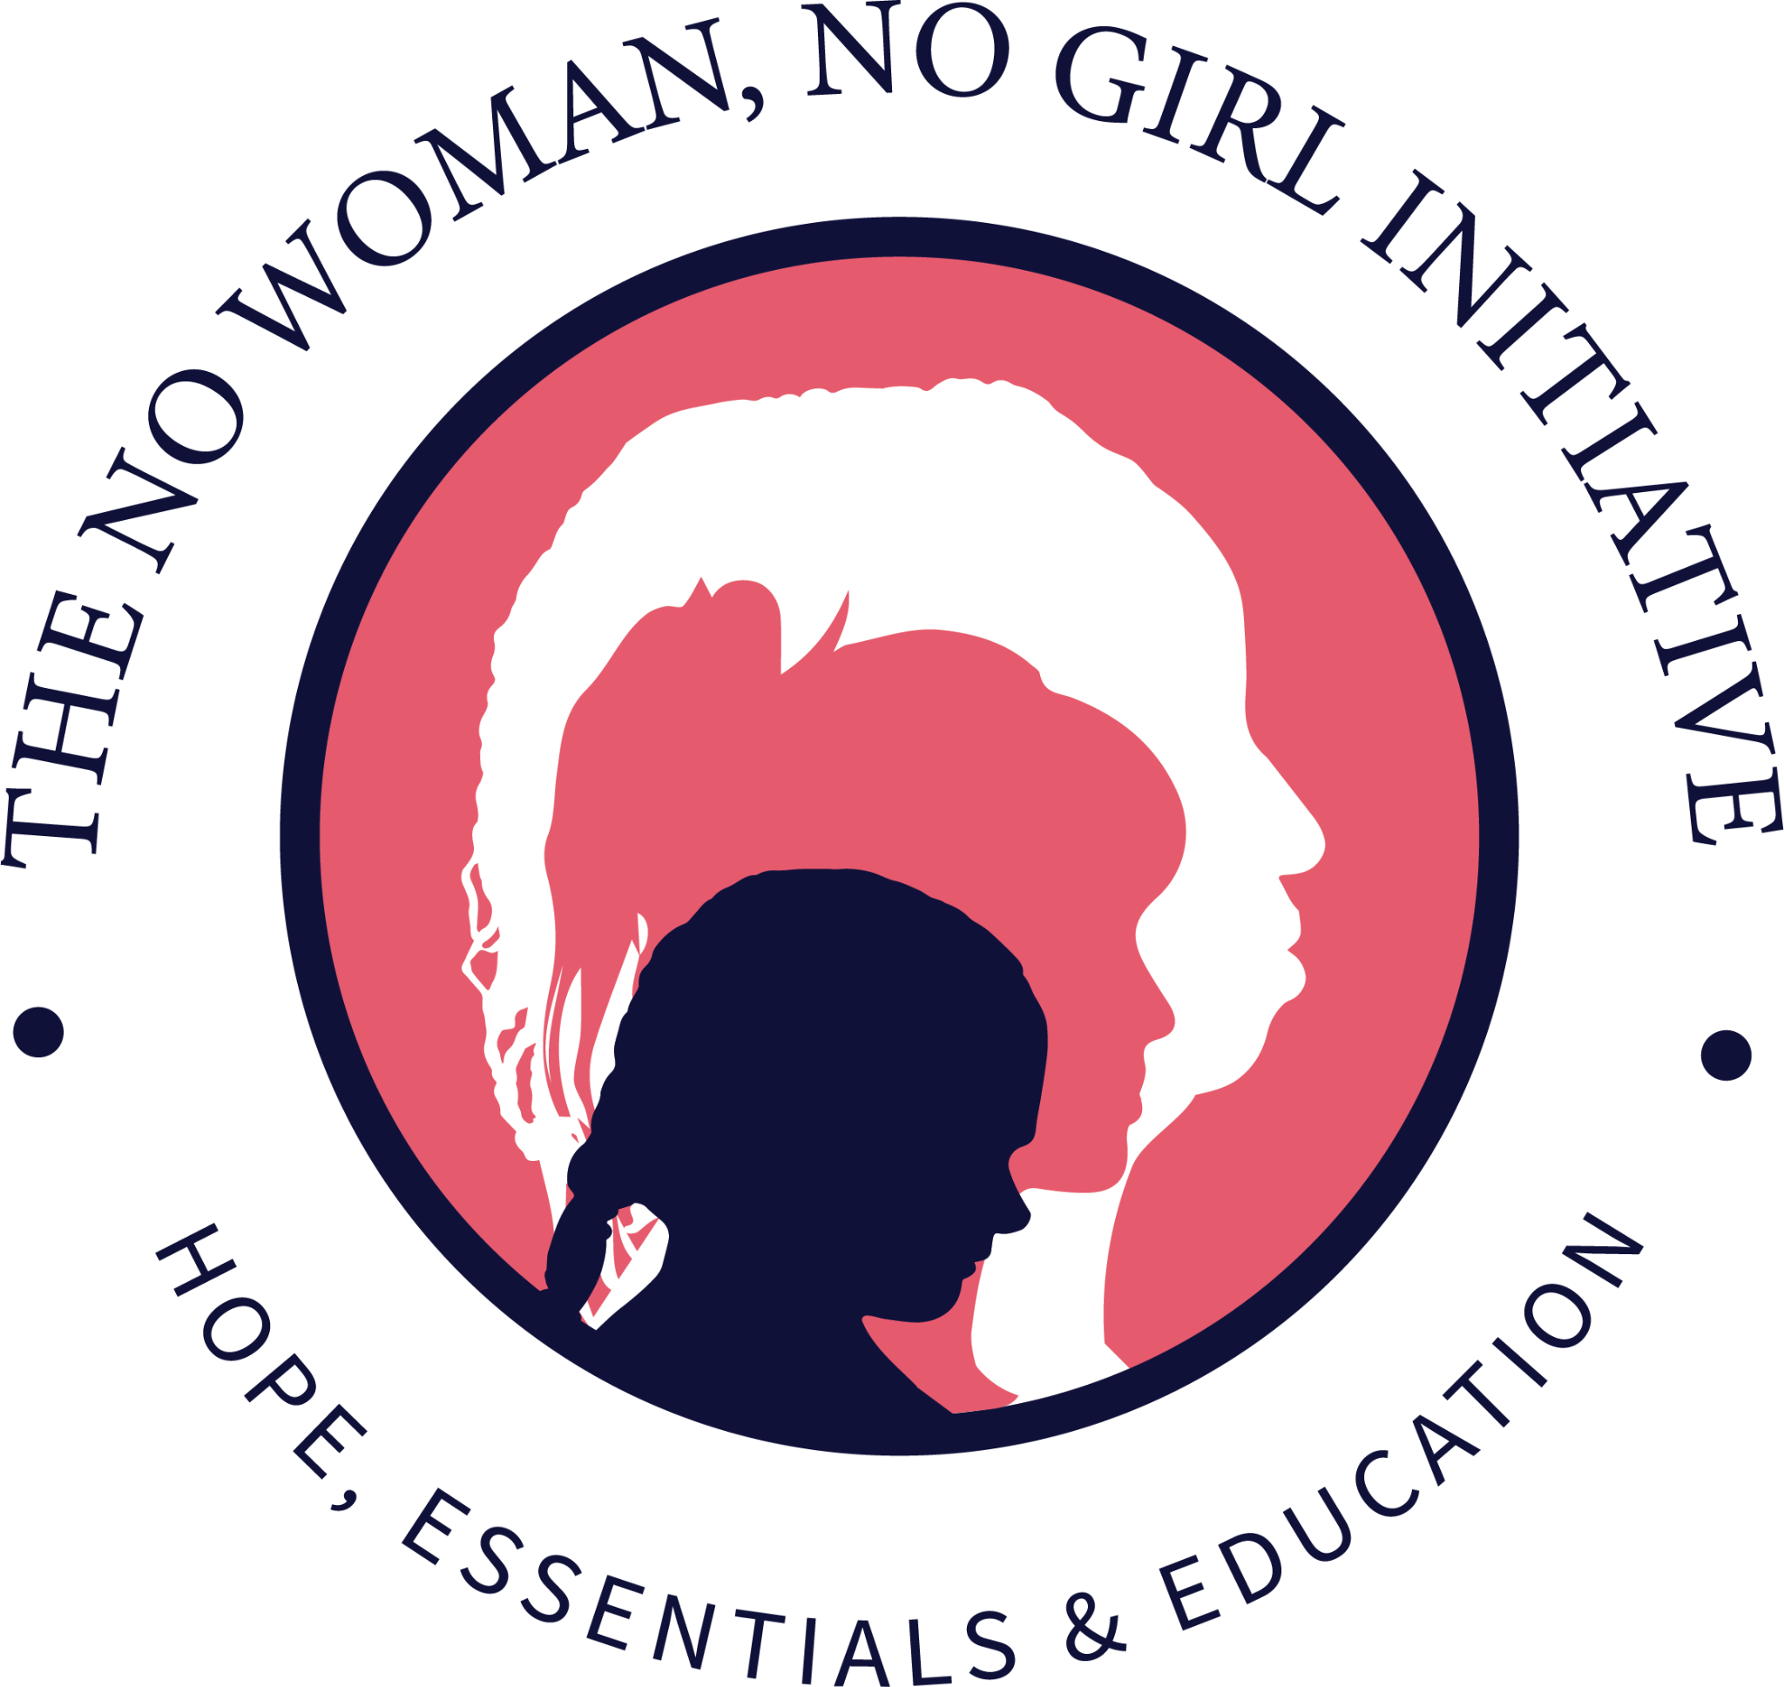

Thank you for supporting women and girls experiencing crisis or transition.
Please place unused and full sized products in the Donation Collection Box!
For more information, please visit www.nowomannogirl.org!

Items We Accept
Shampoo
Conditioner
Floss
Toothpaste
Toothbrushes
Deodorant
Hand sanitizer
Body wash
Bar soap
Body lotion
Washcloths
Pads
Tampons
Pantyliners
Feminine hygiene wipes

